Research and Analysis of Five Similar Software
Overview
The purpose of this research is to analyze five software platforms that are similar to HeartWay’s domain — not identical — in order to understand their technology stacks, interface patterns, user experience strategies, and design approaches.
HeartWay is a GPS-based school bus tracking system designed to help drivers, schools, students, and parents track vehicle movement, improve safety, and ensure better communication.
This comparative study identifies the strengths and unique features of each platform, focusing on their front-end frameworks, back-end infrastructure, UI/UX design, and how these learnings can guide HeartWay’s product design and development.

1. Digital Nepal (https://edigitalnepal.com)
Tech Stack
Front-end: React, React Router, JSS, Emotion (modern component-based UI)
Back-end: Likely Node.js or PHP-based (not publicly disclosed)
Analytics & Tagging: Microsoft Clarity, Google Analytics 4, Facebook Pixel, Google Tag Manager
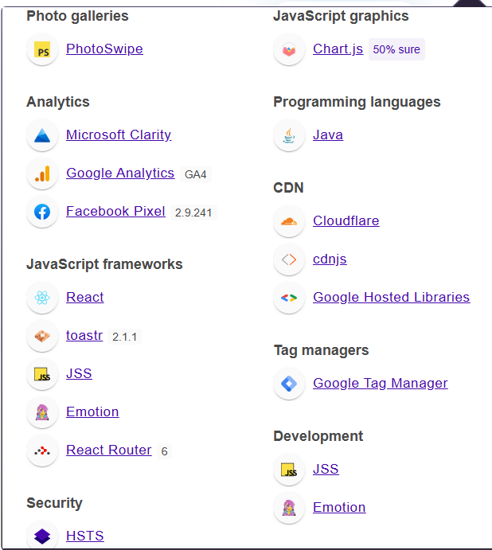
Figure 1: insights gained from wappalizer
Observations
Digital Nepal offers a clean and modern user interface with well-balanced white space, minimal design, and soft color transitions. Its landing page provides a professional yet friendly introduction to its ERP platform.
What I Liked
- The landing page is visually appealing and feels modern and trustworthy.
- React-based front-end ensures high interactivity and smooth component transitions.
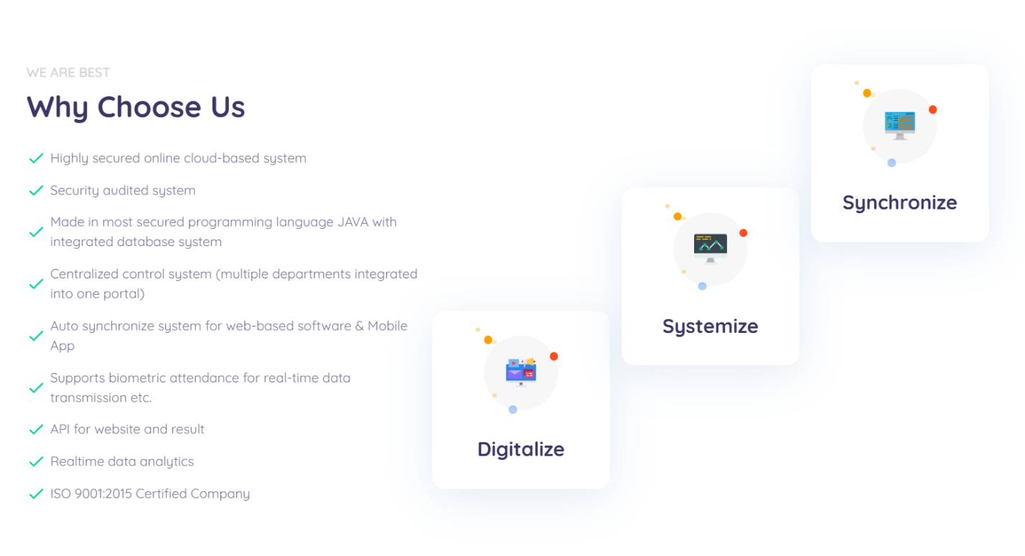
Figure 2: Digital Nepal why choose us
2. Trackon GPS (https://web.trackongps.com)
Tech Stack
Front-end: React, React Router, Vite (fast build tool), Leaflet (map integration)
Back-end: Java (server-side), hosted on Ubuntu OS
Features: PWA (Progressive Web App), Lucide icons, Open Graph integration
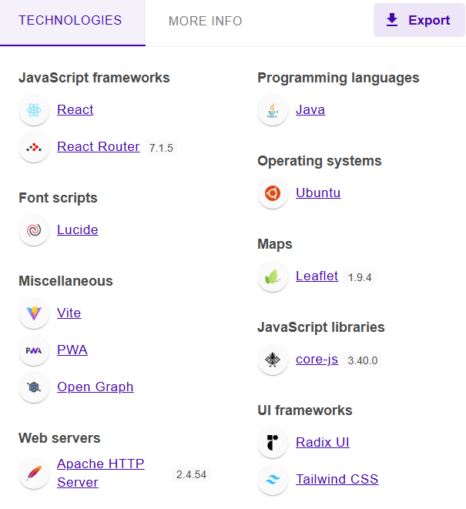
Figure 3: insights gained from Wappalizer of Trackon GPS
Observations
Trackon GPS is a dedicated fleet and vehicle management platform built for real-time tracking. Its simple login interface, reliable map integration, and consistent color palette create a professional user experience.
What I Liked
- The login page is minimalistic, fast-loading, and intuitive.
- Integration of Leaflet.js for live maps is a perfect fit for GPS tracking applications.
- The stack uses React + Vite, known for speed and responsiveness.
- The PWA support enables offline or limited-network access, great for parents or drivers.
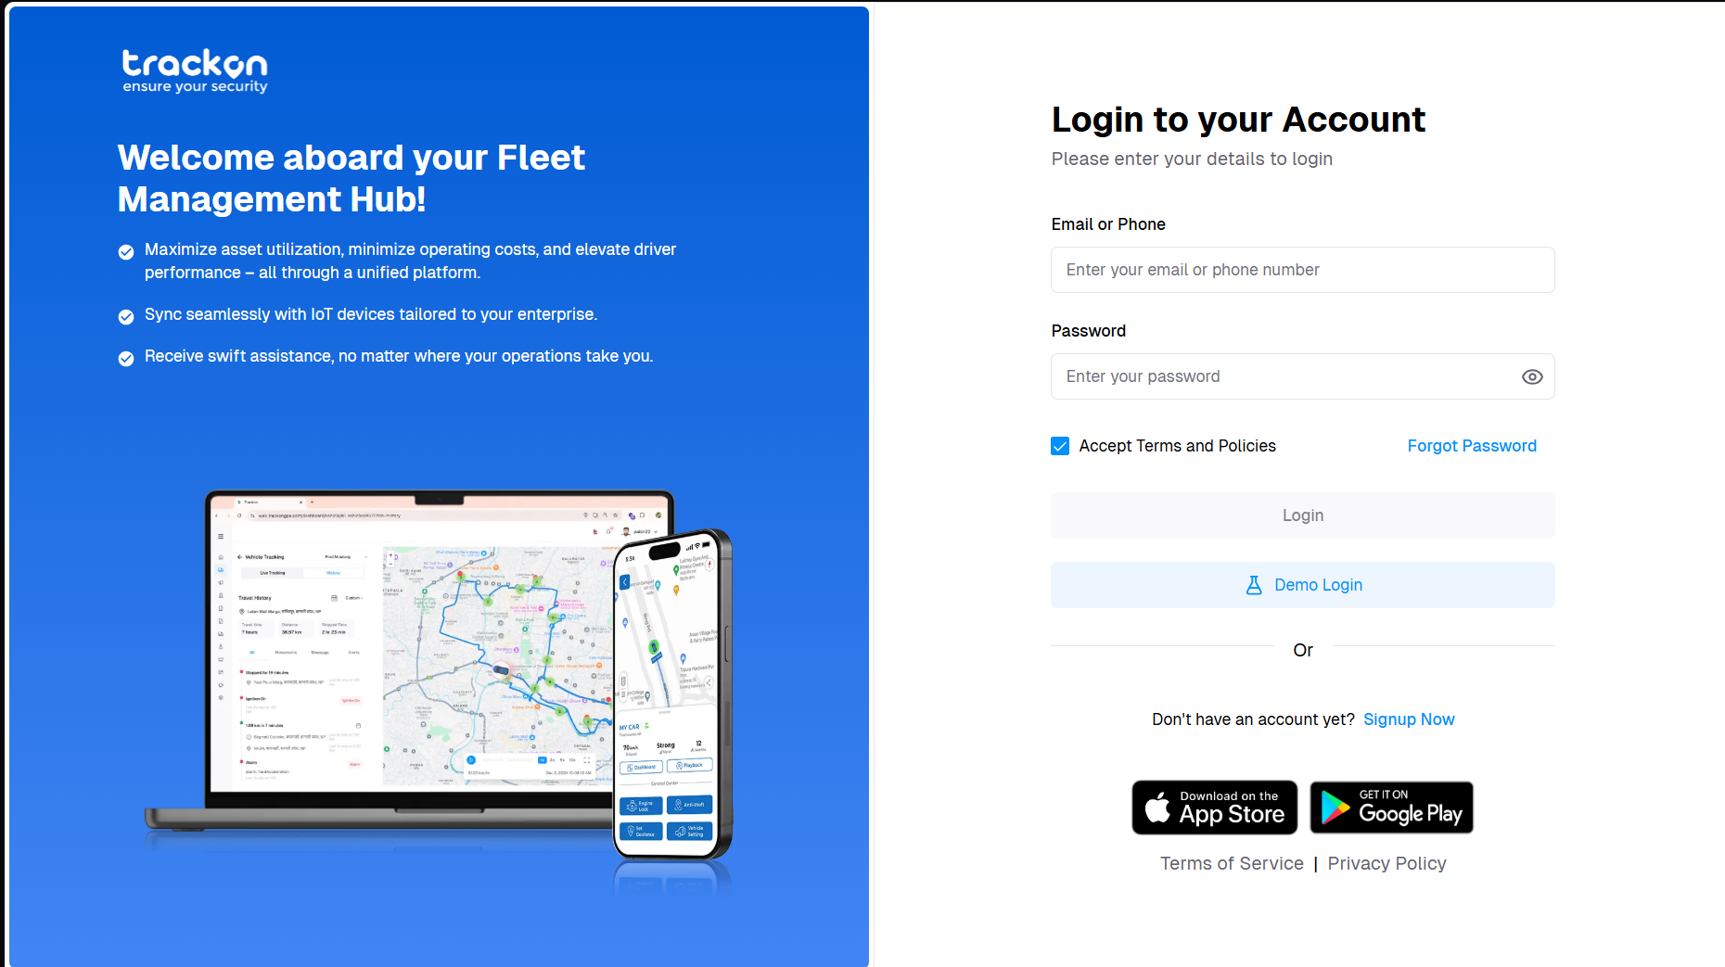
Figure 4: login page of Trackon GPS
3. Veda App (https://veda-app.com)
Tech Stack
Front-end: Next.js (React-based SSR), Emotion (styling), reCAPTCHA (security)
Back-end: Likely Node.js with REST APIs (framework not public)
Analytics & Chat: Microsoft Clarity, Google Analytics 4, Facebook Pixel, Facebook Chat Plugin
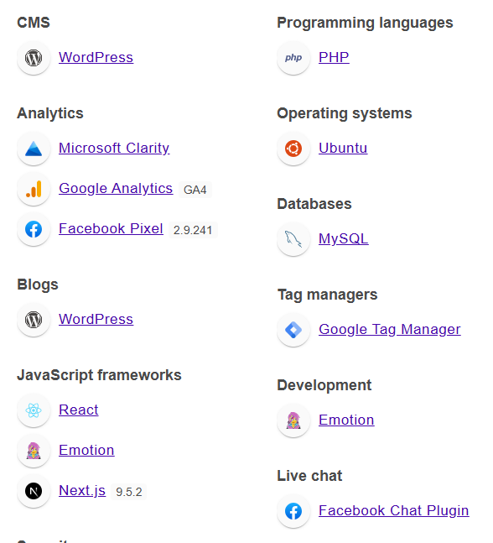
Figure 5: insights Wappalizer of Veda App
Observations
Veda is an advanced school management system that includes GPS tracking among its many modules. It combines a modern user experience with strong lead conversion design through its “Book a Demo” flow.
What I Liked
- The demo booking section is clean, structured, and easy to fill.
- Next.js ensures excellent SEO and fast page loads for marketing pages.
- reCAPTCHA integration adds form security and professionalism.
- Consistent visual style and typography create a strong educational brand.
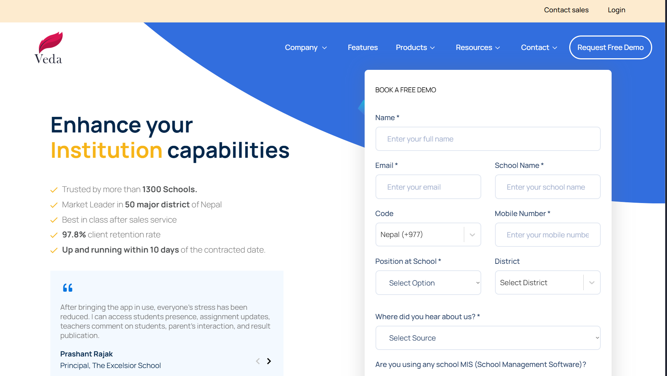
Figure 6: Book a demo page of Veda
4. Fedena (https://fedena.com)
Tech Stack
Front-end: WordPress (CMS), Google Font API
Back-end: PHP (WordPress Core) with MySQL database
Analytics & Advertising: Google Analytics 4, Google Ads Conversion Tracking, Google Tag Manager
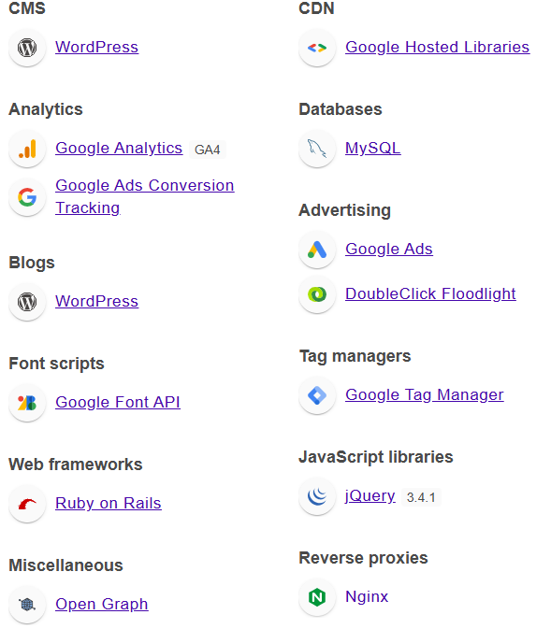
Figure 7: Insights gained of Fedena
Observations
Fedena is a globally recognized school management system offering over 50 modules, including transportation. Its pricing structure and landing layout are clean and professional.
What I Liked
- The pricing and plans page is visually clear and logically structured.
- Tiered pricing cards (Standard, Premium, Ultimate) make plan comparisons easy.
- Uses a consistent red-and-white color palette to maintain brand identity.
- Backend (PHP + MySQL) is stable and cost-effective for SaaS-type deployments.
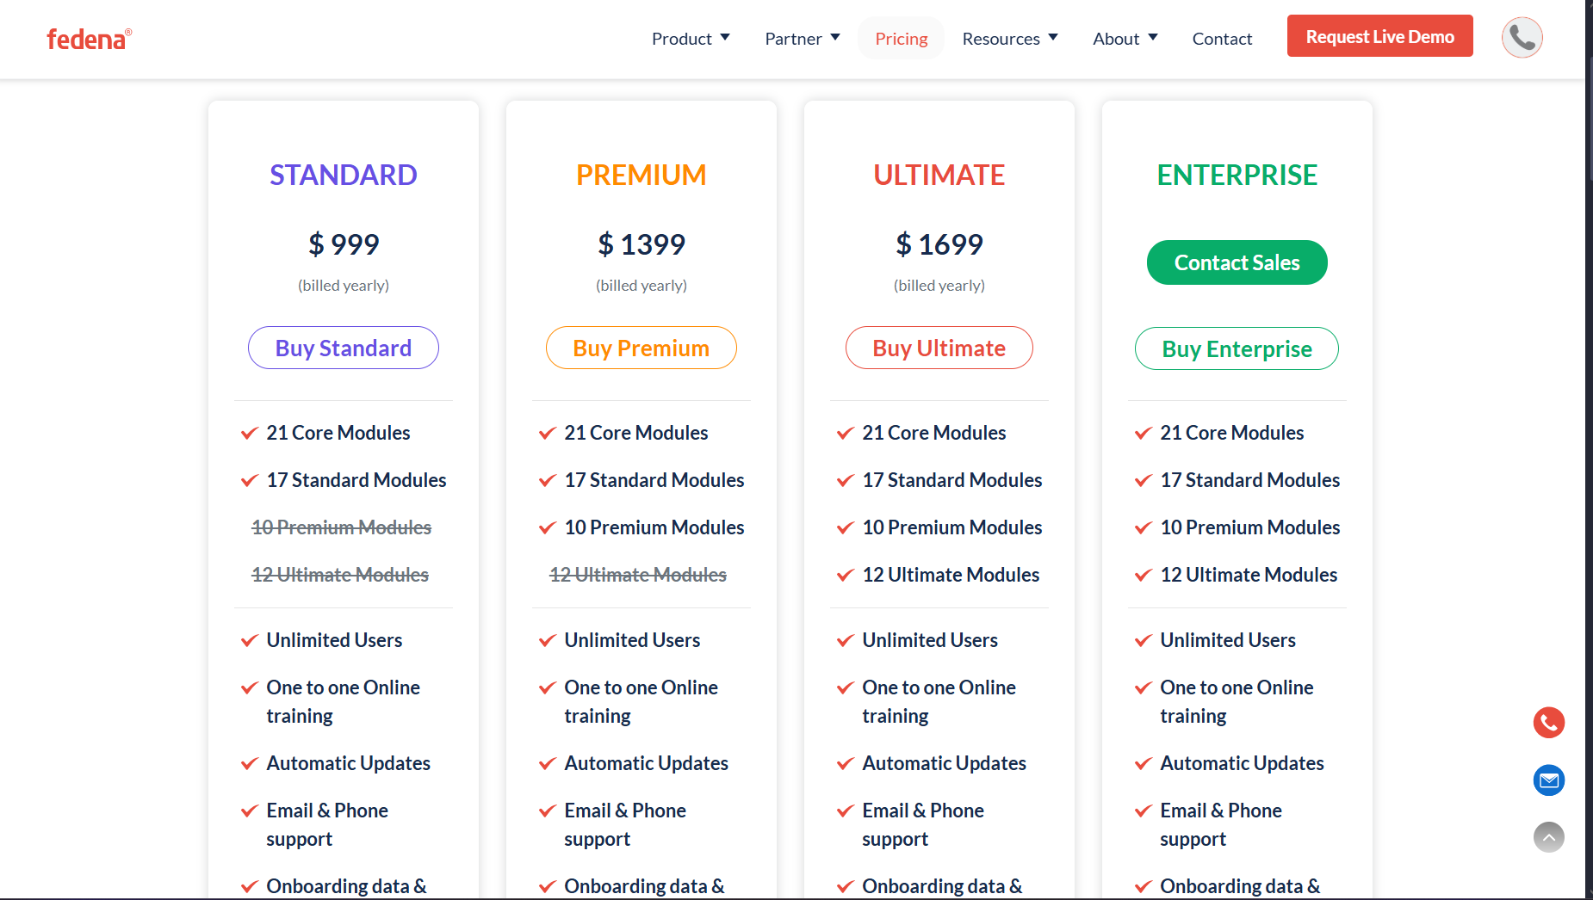
Figure 8: subscription page of Fedena
5. GPS-Server (https://gps-server.net)
Tech Stack
Front-end: WordPress (CMS) + Elementor Page Builder, jQuery UI, LazySizes (lazy loading)
Back-end: PHP with MySQL database
SEO & Analytics: Yoast SEO, Google Analytics 4, Open Graph integration
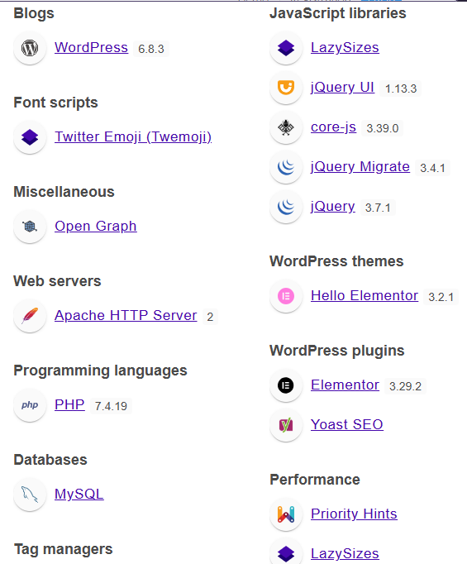
Figure 9: Insights gained of GPS-Server
Observations
GPS-Server is a professional-grade white-label GPS tracking platform supporting over 900 devices. Its landing page balances technical capability with easy-to-read summaries.
What I Liked
- The landing page clearly communicates the platform’s scale and capabilities.
- Good use of WordPress + Elementor for a visually rich, easily editable website.
- Live demo access and transparent metrics (connected devices, uptime) build trust.
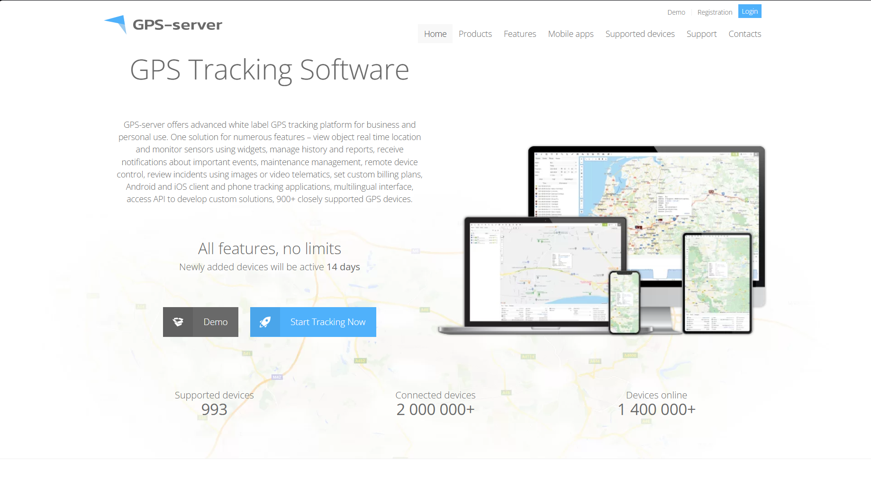
Figure 10: landing page of GPS Server
Summary of Tech Stack Insights
Software | Front-End Stack | Back-End Stack | Key Strength | What HeartWay Can Adopt
Digital Nepal | React, JSS, Emotion | Likely Node.js/PHP | Modern UI + Analytics | Use React for interactivity & modern design
Trackon GPS | React, Leaflet, Vite | Java (API) | Real-time map & PWA | Implement Leaflet + React + Vite stack
Veda App | Next.js (React), Emotion | Node.js (inferred) | Clean demo flow + SEO | Build marketing pages using Next.js
Fedena | WordPress (CMS) | PHP + MySQL | Tiered pricing page | Adapt modular pricing plans
GPS-Server | WordPress + Elementor | PHP + MySQL | Demo + SEO-friendly | Add live demo + SEO optimization
Color Theory

Website | Primary Color | Secondary | Btn Default | Btn Hover | Color Theory
Digital Nepal | #0045B3 | #6F42C1 | #0045B3 | #003A8F | Analogous
Trackon GPS | #0078FF | #1C1C1C | #0078FF | #005FCC | Monochromatic
Veda App | #0056D2 | #F5C542 | #0056D2 | #003FA6 | Complementary
Fedena | #E30613 | #FFB900 | #E30613 | #C00510 | Analogous / Split Complementary
GPS-Server | #0099CC | #333333 | #0099CC | #007DAA | Complementary (Soft)

